Machine Learning Project in Course era

By T Shashank

Below are the steps that I did to go about solving the project.

1. Downloaded the data for both Training & Testing data
2. Examined the training data set to understand the variables that are present and ‘Classe’ is the dependent variable.
3. Cleaned the data set by removing the columns that are irrelevant to the analysis. Made the columns which had NA as 0 as well.
4. Cross validation: For the purpose of cross validation, divided the cleaned training data set into two parts of 70% & 30%
5. Build various models – Decision tree using ‘rpart’, Random forest, Gradient Boosting & Linear discremant analysis and compared the accuracy of each.
6. Found Random forest to be the highest accuracy wit 99.6%

Model 1: Decision Tree

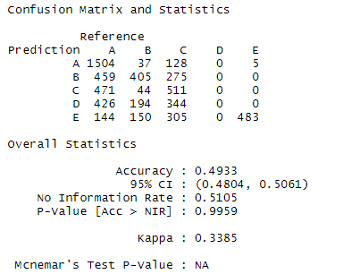

Model 2: Random forest

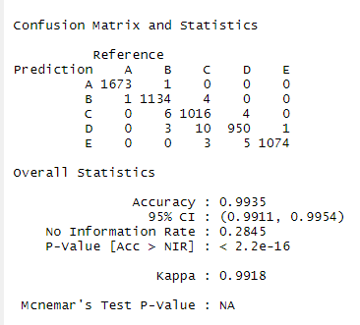

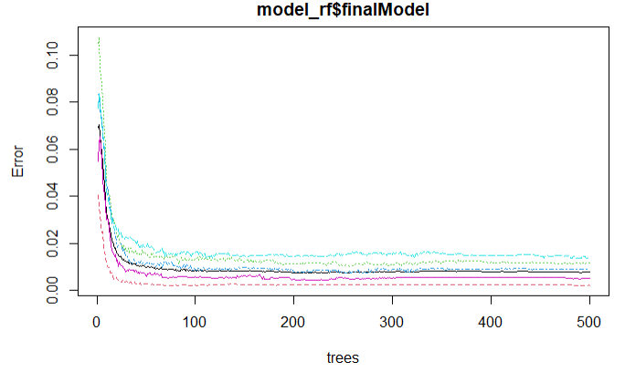

Model 3: Gradient Boosting

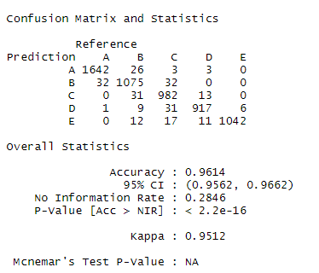

Model 4: Linear discremant Analysis

